CHESS GAME CODE USING PYTHON

ROLL NO A05 06 22

import itertools

WHITE = "white"

BLACK = "black"

class Chess:

def _init_(self):

self.playersturn = BLACK

self.message = "this is where prompts will go"

self.gameboard = {}

self.placePieces()

print("chess program. enter moves in this type of notation ex:e7 e6")

self.main()

#this is for defining places of pieces

def placePieces(self):

for i in range(0,8):

self.gameboard[(i,1)] = Pawn(WHITE,uniDict[WHITE][Pawn],1)

self.gameboard[(i,6)] = Pawn(BLACK,uniDict[BLACK][Pawn],-1)

placers = [Rook,Knight,Bishop,Queen,King,Bishop,Knight,Rook]

for i in range(0,8):

self.gameboard[(i,0)] = placers[i](WHITE,uniDict[WHITE][placers[i]])

self.gameboard[((7-i),7)] = placers[i](BLACK,uniDict[BLACK][placers[i]])

placers.reverse()

def main(self):

while True:

self.printBoard()

print(self.message)

self.message = ""

startpos,endpos = self.parseInput()

try:

target = self.gameboard[startpos]

except:

self.message = "could not find piece; index probably out of range"

target = None

if target:

print("found "+str(target))

if target.Color != self.playersturn:

self.message = "you aren't allowed to move that piece this turn"

continue

if target.isValid(startpos,endpos,target.Color,self.gameboard):

self.message = "that is a valid move"

self.gameboard[endpos] = self.gameboard[startpos]

del self.gameboard[startpos]

self.isCheck()

if self.playersturn == BLACK:

self.playersturn = WHITE

else : self.playersturn = BLACK

else :

self.message = "invalid move" + str(target.availableMoves(startpos[0],startpos[1],self.gameboard))

print(target.availableMoves(startpos[0],startpos[1],self.gameboard))

else : self.message = "there is no piece in that space"

# for king ,check all black piece if it hits the king or is it checkmate

def isCheck(self):

king = King

kingDict = {}

pieceDict = {BLACK : [], WHITE : []}

for position,piece in self.gameboard.items():

if type(piece) == King:

kingDict[piece.Color] = position

print(piece)

pieceDict[piece.Color].append((piece,position))

#white

if self.canSeeKing(kingDict[WHITE],pieceDict[BLACK]):

self.message = "White player is in check"

if self.canSeeKing(kingDict[BLACK],pieceDict[WHITE]):

self.message = "Black player is in check"

#checks if any pieces in piece list (which is an array of (piece,position) tuples) can see the king in kingpos

def canSeeKing(self,kingpos,piecelist):

for piece,position in piecelist:

if piece.isValid(position,kingpos,piece.Color,self.gameboard):

return True

#input method for game in algebraic notation

def parseInput(self):

try:

a,b = input().split()

a = ((ord(a[0])-97), int(a[1])-1)

b = (ord(b[0])-97, int(b[1])-1)

print(a,b)

return (a,b)

except:

print("error decoding input. please try again")

return((-1,-1),(-1,-1))

"""def validateInput(self, *kargs):

for arg in kargs:

if type(arg[0]) is not type(1) or type(arg[1]) is not type(1):

return False

return True"""

# printing of chess board in without gui

def printBoard(self):

print(" 1 | 2 | 3 | 4 | 5 | 6 | 7 | 8 |")

for i in range(0,8):

print("+"*32)

print(chr(i+97),end="|")

for j in range(0,8):

item = self.gameboard.get((i,j)," ")

print(str(item)+' |', end = " ")

print()

print("+"*32)

"""game class. contains the following members and methods:

two arrays of pieces for each player

8x8 piece array with references to these pieces

a parse function, which turns the input from the user into a list of two tuples denoting start and end points

a checkmateExists function which checks if either players are in checkmate

a checkExists function which checks if either players are in check (woah, I just got that nonsequitur)

a main loop, which takes input, runs it through the parser, asks the piece if the move is valid, and moves the piece if it is. if the move conflicts with another piece, that piece is removed. ischeck(mate) is run, and if there is a checkmate, the game prints a message as to who wins

"""

# piece color,name are defined

class Piece:

def _init_(self,color,name):

self.name = name

self.position = None

self.Color = color

def isValid(self,startpos,endpos,Color,gameboard):

if endpos in self.availableMoves(startpos[0],startpos[1],gameboard, Color = Color):

return True

return False

def _repr_(self):

return self.name

def _str_(self):

return self.name

def availableMoves(self,x,y,gameboard):

print("ERROR: no movement for base class")

def AdNauseum(self,x,y,gameboard, Color, intervals):

"""repeats the given interval until another piece is run into.

if that piece is not of the same color, that square is added and

then the list is returned"""

answers = []

for xint,yint in intervals:

xtemp,ytemp = x+xint,y+yint

while self.isInBounds(xtemp,ytemp):

#print(str((xtemp,ytemp))+"is in bounds")

target = gameboard.get((xtemp,ytemp),None)

if target is None: answers.append((xtemp,ytemp))

elif target.Color != Color:

answers.append((xtemp,ytemp))

break

else:

break

xtemp,ytemp = xtemp + xint,ytemp + yint

return answers

#"checks if position is on the board or available "

def isInBounds(self,x,y):

if x >= 0 and x < 8 and y >= 0 and y < 8:

return True

return False

"checks if a single position poses no conflict to the rules of chess"

def noConflict(self,gameboard,initialColor,x,y):

if self.isInBounds(x,y) and (((x,y) not in gameboard) or gameboard[(x,y)].Color != initialColor) : return True

return False

chessCardinals = [(1,0),(0,1),(-1,0),(0,-1)]

chessDiagonals = [(1,1),(-1,1),(1,-1),(-1,-1)]

#moves of all pieces defined by each class and method of its name

def knightList(x,y,int1,int2):

"""sepcifically for the rook, permutes the values needed around a position for noConflict tests"""

return [(x+int1,y+int2),(x-int1,y+int2),(x+int1,y-int2),(x-int1,y-int2),(x+int2,y+int1),(x-int2,y+int1),(x+int2,y-int1),(x-int2,y-int1)]

def kingList(x,y):

return [(x+1,y),(x+1,y+1),(x+1,y-1),(x,y+1),(x,y-1),(x-1,y),(x-1,y+1),(x-1,y-1)]

class Knight(Piece):

def availableMoves(self,x,y,gameboard, Color = None):

if Color is None : Color = self.Color

return [(xx,yy) for xx,yy in knightList(x,y,2,1) if self.noConflict(gameboard, Color, xx, yy)]

class Rook(Piece):

def availableMoves(self,x,y,gameboard ,Color = None):

if Color is None : Color = self.Color

return self.AdNauseum(x, y, gameboard, Color, chessCardinals)

class Bishop(Piece):

def availableMoves(self,x,y,gameboard, Color = None):

if Color is None : Color = self.Color

return self.AdNauseum(x, y, gameboard, Color, chessDiagonals)

class Queen(Piece):

def availableMoves(self,x,y,gameboard, Color = None):

if Color is None : Color = self.Color

return self.AdNauseum(x, y, gameboard, Color, chessCardinals+chessDiagonals)

class King(Piece):

def availableMoves(self,x,y,gameboard, Color = None):

if Color is None : Color = self.Color

return [(xx,yy) for xx,yy in kingList(x,y) if self.noConflict(gameboard, Color, xx, yy)]

class Pawn(Piece):

def _init_(self,color,name,direction):

self.name = name

self.Color = color

# direction should be either 1 or -1, should be -1 if the pawn is traveling "backwards"

self.direction = direction

#this is to show all available moves for the selected pieces

def availableMoves(self,x,y,gameboard, Color = None):

if Color is None : Color = self.Color

answers = []

if (x+1,y+self.direction) in gameboard and self.noConflict(gameboard, Color, x+1, y+self.direction) : answers.append((x+1,y+self.direction))

if (x-1,y+self.direction) in gameboard and self.noConflict(gameboard, Color, x-1, y+self.direction) : answers.append((x-1,y+self.direction))

if (x,y+self.direction) not in gameboard and Color == self.Color : answers.append((x,y+self.direction))# the condition after the and is to make sure the non-capturing movement (the only fucking one in the game) is not used in the calculation of checkmate

return answers

#used dicitionary for printing the pic of all black and white pieces

uniDict = {WHITE : {Pawn : "♙", Rook : "♖", Knight : "♘", Bishop : "♗", King : "♔", Queen : "♕" }, BLACK : {Pawn : "♟", Rook : "♜", Knight : "♞", Bishop : "♝", King : "♚", Queen : "♛" }}

Chess()

This is interface of the program output:

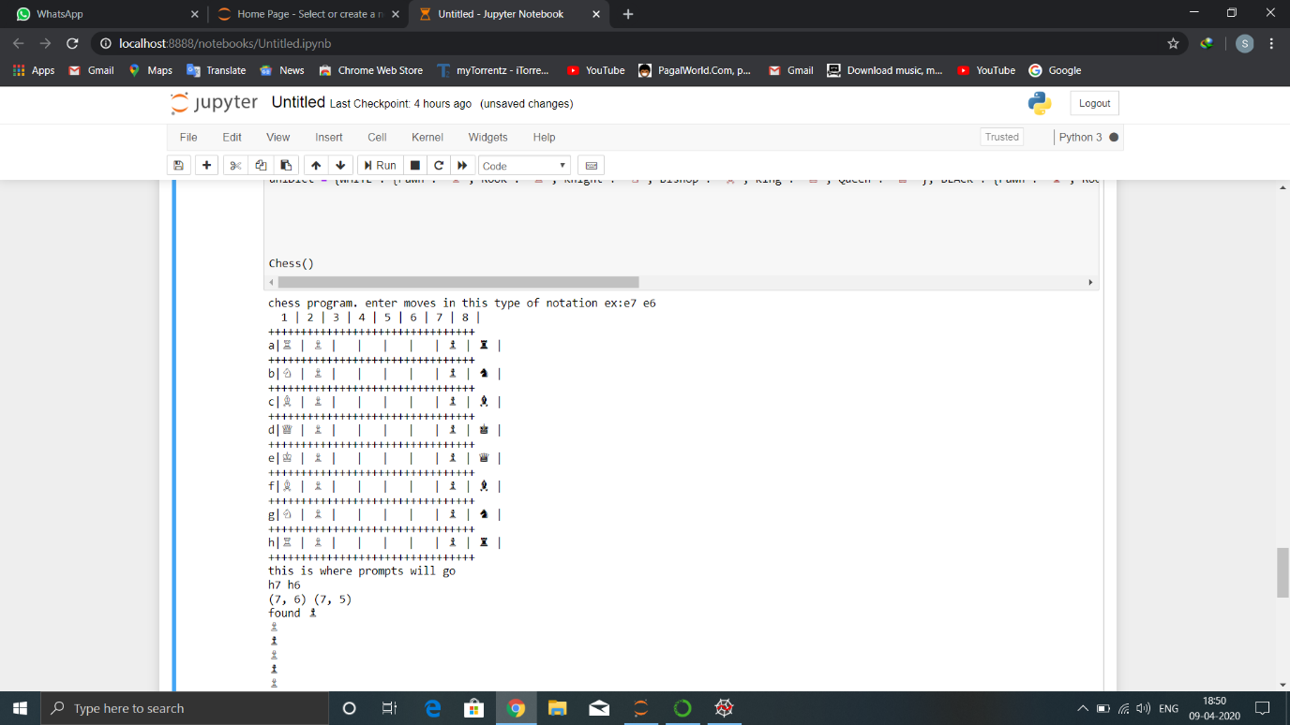

Here we make a move in algebraic notation like h7 h6 i.e.(h7 place piece will go to h6)

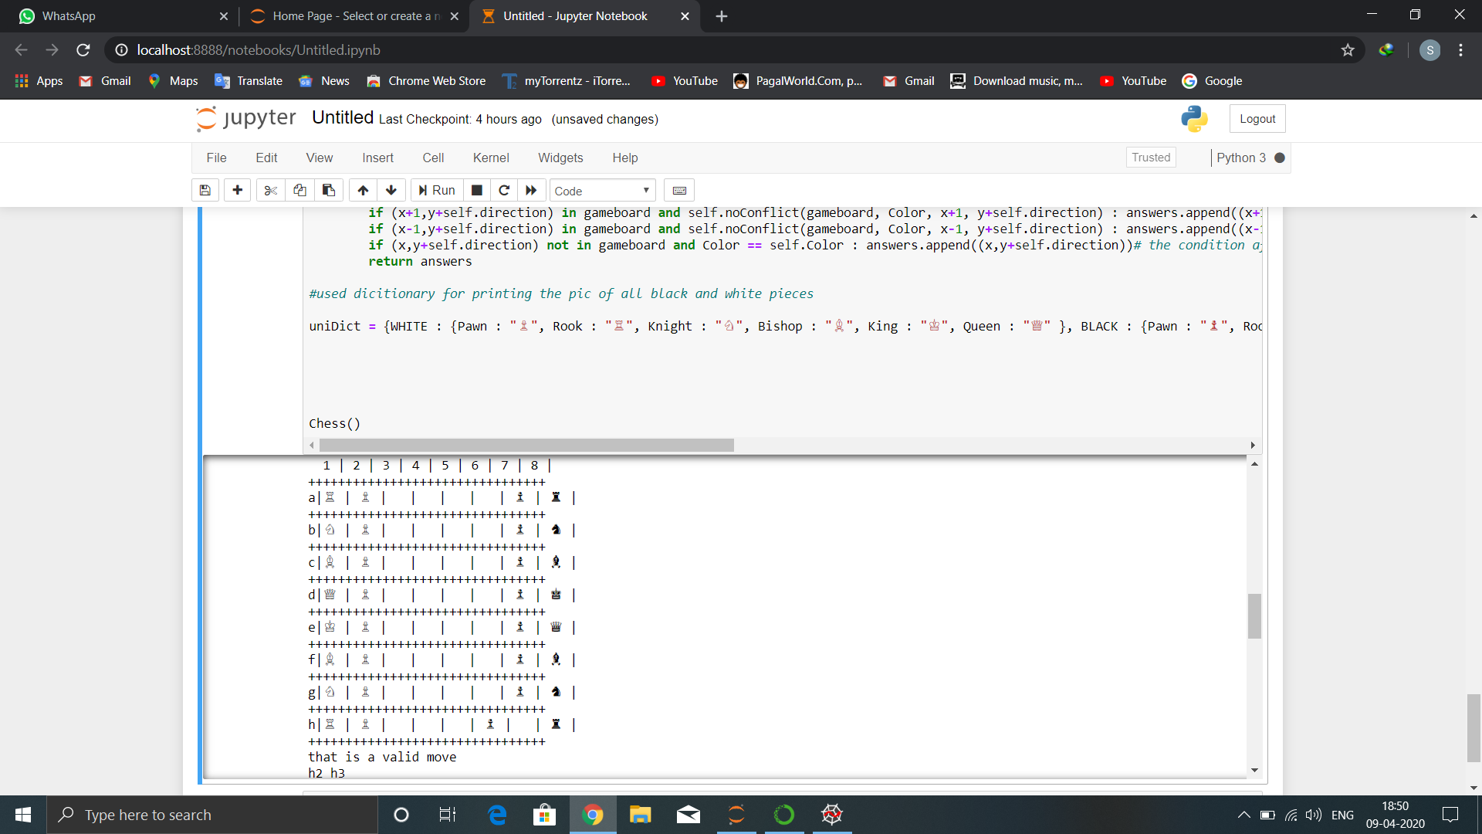

Here we made the opponent move i.e.h2 h3

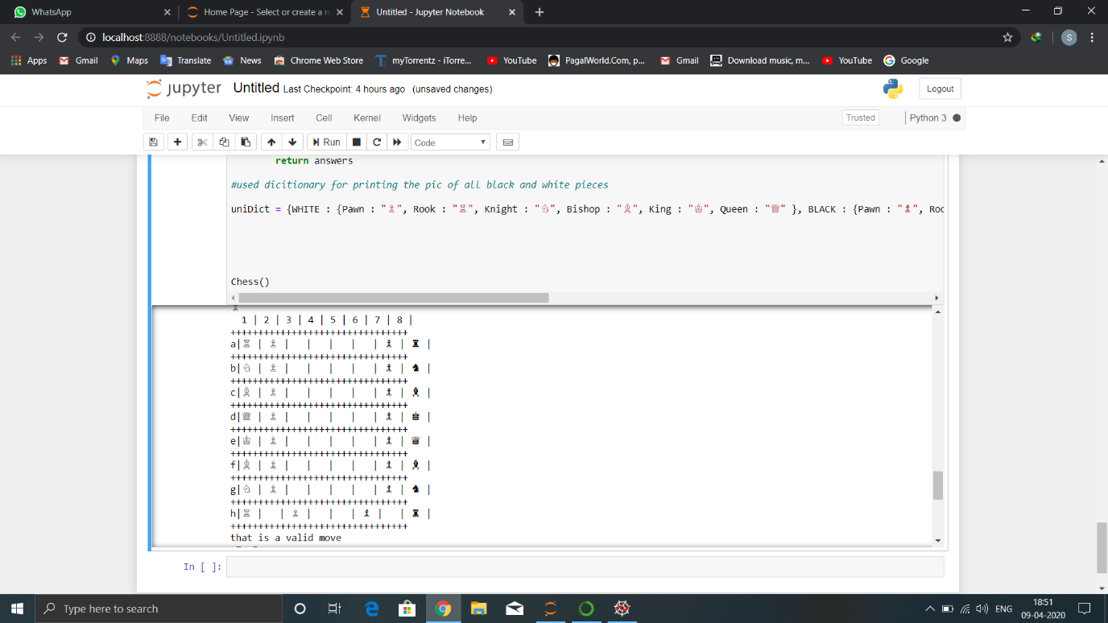

Here we call a wrong move so it shows invalid move.

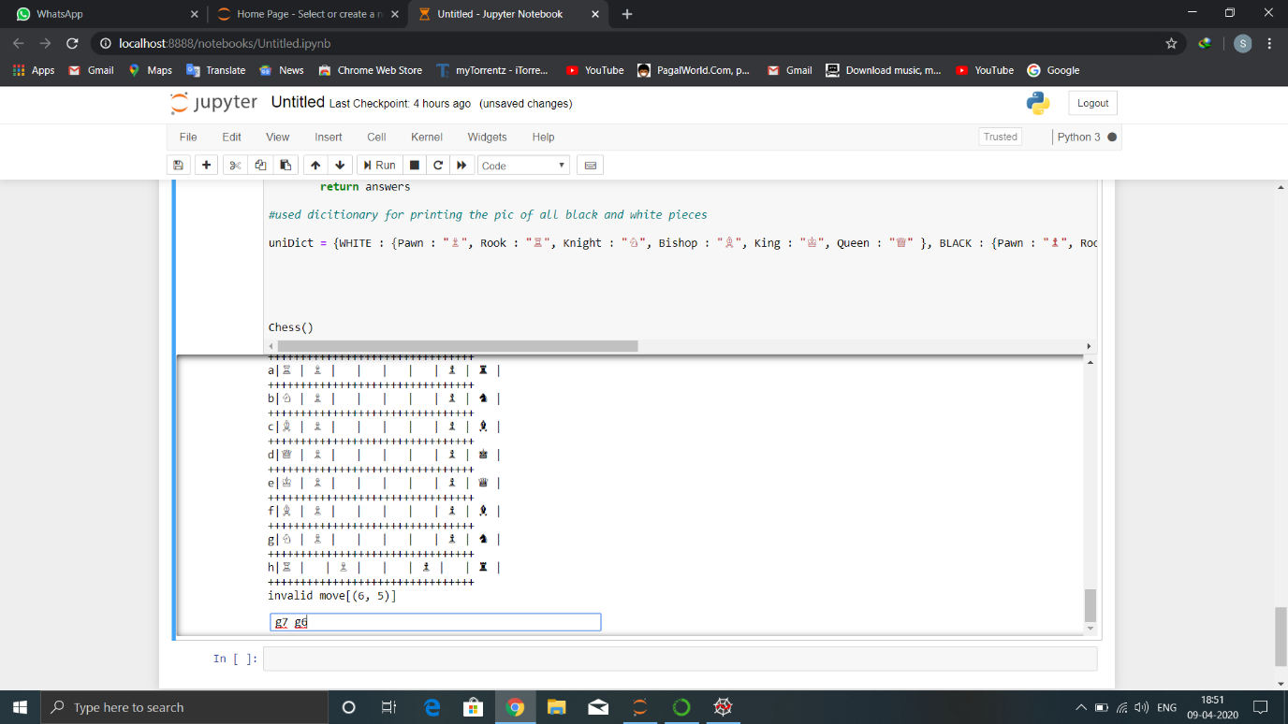

Here we move g7 g6:

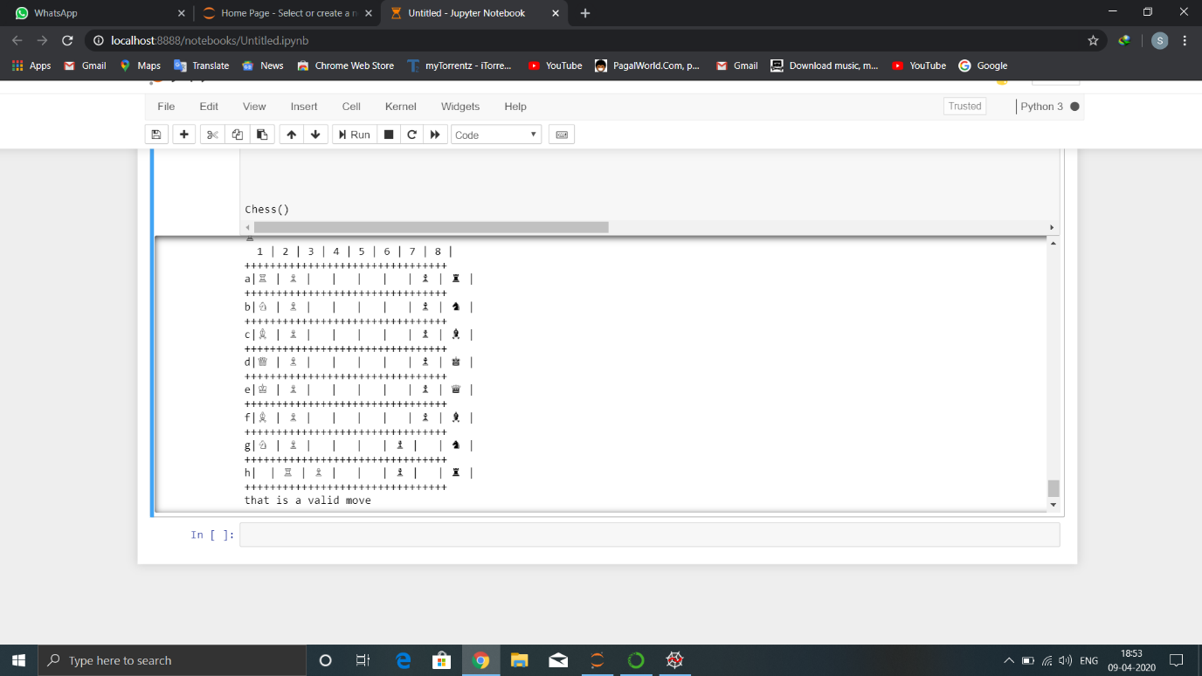

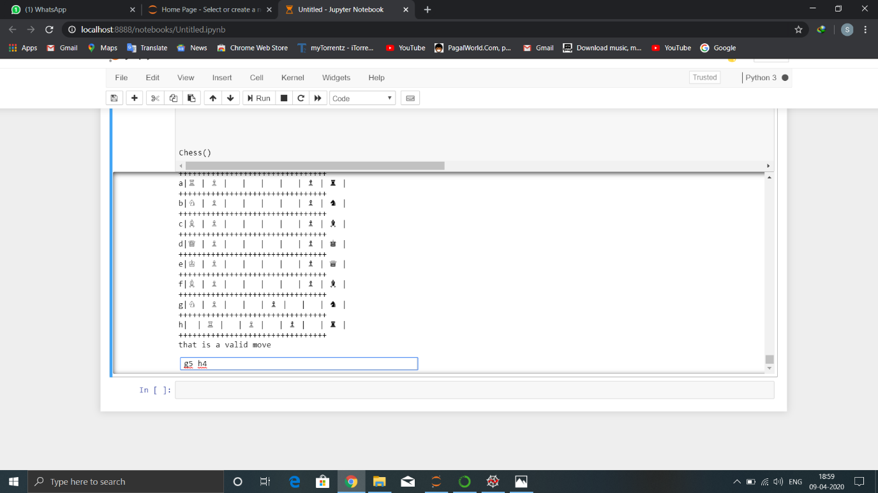

In this we make a move to eliminate one of white piece:

